**HOW TO SET UP AND USE CALDERA**

Navigate to <https://github.com/mitre/caldera>

Follow install instructions in kali linux

Boot command panel

# apt install git

# apt install python3

# git clone https://github.com/mitre/caldera.git --recursive

# cd caldera

#pip3 install -r requirements.txt

IF THIS ERROR COMES UP, FOLLOW THESE STEPS

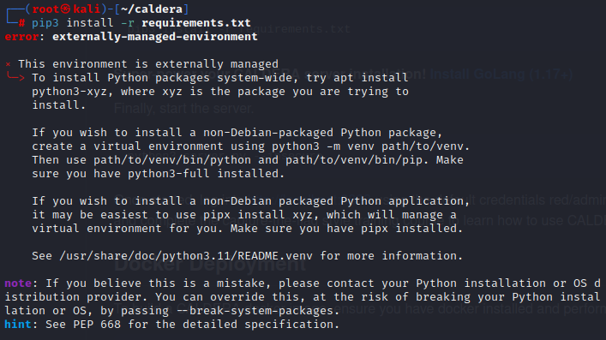

# python3 -m venv .venv

# source .venv/bin/activate

# pip3 install -r requirements.txt

# python3 server.py –insecure

Open Firefox mozilla

Navigate to <http://localhost:8888>

Username: red

Password: admin

**DONE WITH INSTALLATION AND BOOT PROCESS**